Justification document

**Senior Software Engineer – Safaricom Garage**

Version 1.0

Contents

1. Revision History 3
2. Definitions, Acronyms and Abbreviations 3
3. Document Reference 3
4. What’s New in this Version 4
5. Introduction 4
6. Choice of System 4
7. System overview 5

Connectivity 6

Oracle Java JDK version 6

OS User 6

1. Deployment Activities 7

Java Clients 7

Step 00 – creating a workbench directory 7

Step 01 – copying files 7

Step 02 – Configuring Java Keystore 7

Cron configuration 8

Database 9

1. Rollback plan 9
2. Deployment Impact 9
3. Artifacts 10

Database Details 10

MERCHANT SETTLEMENT PRODUCTION DB 10

Deployment Files 10

# Revision History

|  |  |  |  |
| --- | --- | --- | --- |
| Date | Version | Description | Revised By |
| 1st August, 2017 | 1.0 | 1st Draft Version | Steve Mutungi |
|  |  |  |  |
|  |  |  |  |

# Definitions, Acronyms and Abbreviations

|  |  |
| --- | --- |
| Abbreviation |  |
|  |  |
|  |  |
|  |  |
|  |  |
|  |  |
|  |  |
|  |  |
|  |  |

# Document Reference

|  |  |
| --- | --- |
| **Document Title** | **Author(s)** |
|  |  |
|  |  |
|  |  |

# What’s New in this Version

|  |
| --- |
| Notes: |
| * Initial justification document for choice of system, the rationale behind it and the delivery approach. |

# Introduction

This document highlights the delivery approach, choice of system, rationale for the decisions made given the constraints etc.

# Effort Used and Rationale behind

Most of the effort has been spent doing design, 60%. 40% has been used developing/implementing the system. This is based on industry experience in getting it right the first time.

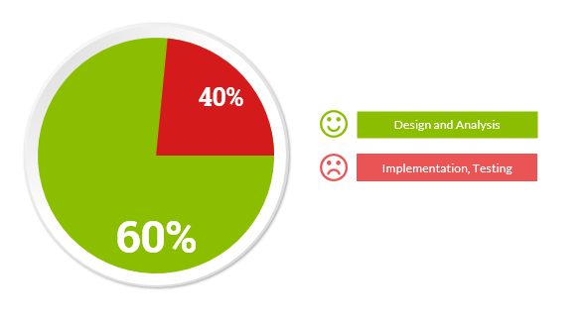

As a senior software Engineer, this is 60:40 percentages still applies. Software engineers can develop the 40% as long as the design is clear.

# Choice of System

With the current political agenda on top of every Kenyan mind, I have chosen to develop and showcase IEBC system.

In any successful enterprise, we must consider the 3 items:

* People
* Systems
* Processes

This justification focuses mostly on systems aspect as the rest are already taken care of.

For any growing and maturing democracy, having a system that is robust, scalable, with omni-channel is preferred.

The IEBC system will utilize several APIs.

|  |  |  |
| --- | --- | --- |
| API Name | API Source | Comments |
| Authentication | Use of Kenyan government OneID for eCitizen | This uses Auth2.0 |
| Publishing IEBC results for different categories e.g. Presidential, governors, MP, Senators | OpenData system by Kenyan Govt |  |
| Facebook and Twitter posts | By Facebook and Twitter(OpenAPIs) |  |
| Google Maps | Gets your current location and the nearest point of interest – your voting polling station |  |
| Uber API | For estimating fare to the nearest polling station. |  |
| Internal APIs(private APIs) | Used to get data from the field by returning officers |  |

# System overview

The figure below highlights the key components of the system.

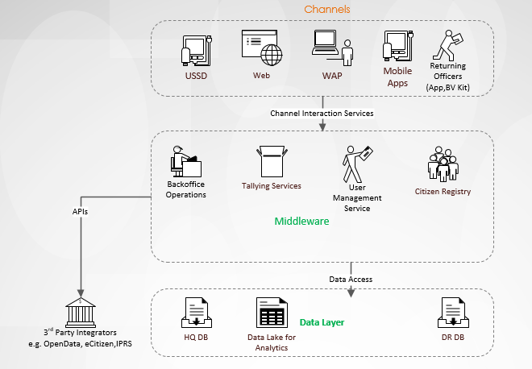

|  |  |  |  |
| --- | --- | --- | --- |
| Component | Category | Justification | Comments |
| USSD | Channels | To be used by Citizens to confirm registration details.Acts as backup for returning officers. | Should be accessible via one short code for all the Telcos |
| WEB | Channels | This has several facets: Backend portal for administration functions 🡺 **Spring Java Web highly recommended due to security considerations.**  Citizen portal to query registration details, search for IEBC official results etc. 🡺 **Laravel framework recommended.** | Internal portal is only available internally (local network). Public portals are accessible via public interfaces e.g. internet or public IPs. |
| WAP | Channels |  | This is a responsive version of the Web. |
| Mobile Apps (iOS, Android) | Channels |  |  |
| Micro-services | Middleware | This uses microservices architecture that can be deployed on Docker to serve several functions e.g. tallying, authentication, external communication with other APIs e.g. IPRS etc. |  |
| Data and Analytics layer | This constitutes of both RDBMS and non-structured DBMS. Data lakes are used for data aggregation and visualization to establish and answer the WHY (goes beyond WHAT). |  |  |
|  |  |  |  |

# Delivery Package

The delivery package committed on GitHub includes the following:

|  |  |  |
| --- | --- | --- |
| Component | Details | Comments |
| Mobile App | Uses Google Map API to get your coordinates, fetches the nearest polling station |  |
| Uber API | To estimate fare to the polling station. |  |
| WEB/WAP | Has analytics and dashboards. |  |